Brian Kirby
Professor & Deputy Dean, International College of Pharmaceutical Innovation,
School of Pharmacy and Biomolecular Sciences,
RCSI University of Medicine and Health Sciences’
Dublin 2
bkirby@rcsi.com
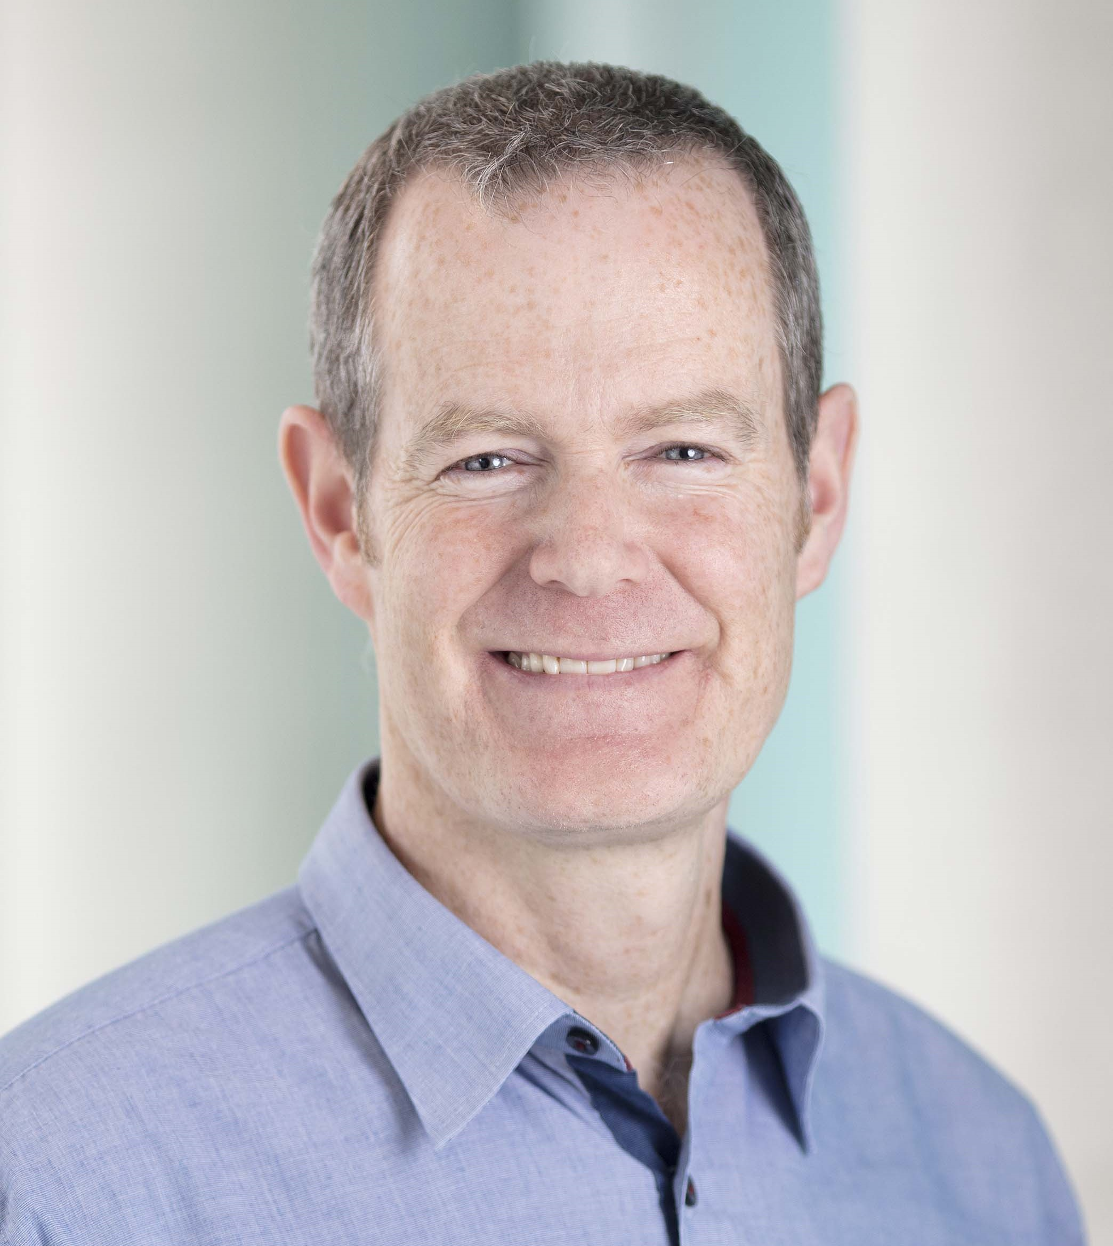

Photo

Brief biography (200 words maximum):

Brian Kirby is a pharmacy graduate (1996) and scholar of Trinity College, Dublin and went on to complete a PhD in neuropharmacology (2000) with Prof Graham Shaw in TCD. Following this he undertook post-doctoral research in the University of Oxford, investigating novel treatments for Alzheimer's and Parkinson's diseases with Prof JNP Rawlins (Experimental Psychology) and Prof S Greenfield (Pharmacology).
Prof Kirby joined the RCSI School of Pharmacy in 2003 and established the pharmacology teaching within the School. From 2011-2014, Prof Kirby was seconded to Kuala Lumpur, Malaysia as the foundation Lead in Clinical Pharmacology in the new RCSI Medical School at Perdana University. Prof Kirby is currently the RCSI Dean for the Joint Education Institute with Soochow University, the International College of Pharmaceutical Innovation, which welcomed its first students in September 2024.
His research interests have centred around the modelling of neurodegenerative and other CNS disorders (AD, PD, Schizophrenia, stroke, learning and memory) and has worked with collaborators in Ireland, Malaysia and China.

Abstract (~200 words):

Modelling and interpreting neurodegenerative diseases in rodents

Neurodegenerative disorders have significant impact on patients and have proven difficult to treat. No matter the root cause, neuroinflammation often forms a key part of the neurodegenerative process, resulting in widespread cell injury and death. The neurodegenerative changes cause cellular changes which can manifest as behavioural changes. Rodent models of human diseases accurately and reproducibly capturing their pathology are key tools in furthering our understanding of the mechanisms behind these diseases and in the development of novel treatment approaches. Animal models of neurodegenerative diseases (and other CNS conditions) are very complex, often with multifactorial inputs into their development and progression. This complexity is a significant challenge which can limit the conduct, analysis and interpretation of the model results. This talk will focus on disease model end-points and, in particular, behavioural phenotyping which, while appearing relatively straightforward, has the potential to be poorly conducted and the results misinterpreted.

